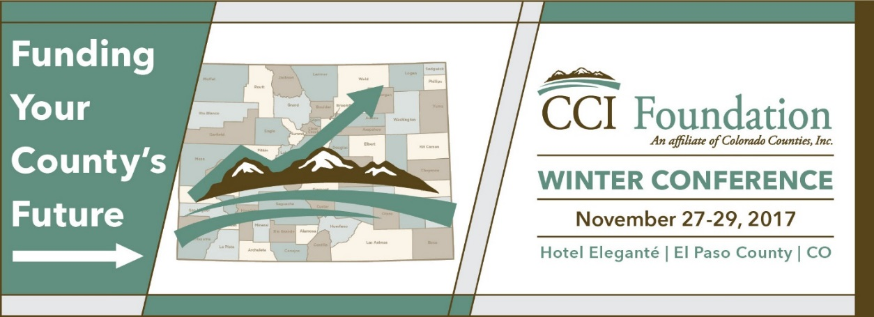

Annual Winter Conference
November 27-29, 2017

Tentative Schedule
(revised November 16, 2017)

Monday, November 27, 2017

9 am – Noon CWAC Meeting

1 pm – 6 pm Registration Open

2 pm – 5 pm CARSE Board of Directors Meeting

2:30 pm – 4 pm CCI/CDOR Quarterly Meeting on Sales Tax

2:30 pm – 4 pm Pre-Conference Workshops

- Alternative Agricultural Water Transfer Methods

- Cybersecurity Training for Elected Officials

4 pm – 5 pm CCI Public Lands

4 pm – 5 pm Meet Sponsors at Tabletop Displays

5 pm – 7 pm President’s Reception (sponsored by Wagner Equipment)

Tuesday, November 28, 2017

7 am – 5 pm Registration Open

7 am – 8:45 am Breakfast for all Delegates (sponsored by CTSI)

Tuesday, November 28, 2017 (continued)

7:30 am – 8:45 am County Workers Compensation Pool & Colorado Counties Casualty & Property Pool Meeting

8:45 am – 9 am Meet Sponsors at Tabletop Displays

7:45 am – 8:45 am CARSE Member Meeting

9 am – 10:15 am Opening Session: What’s Ahead for the Colorado Economy

Rich Wobbekind, Leeds School of Business, UC-Boulder

10:15 am – 10:30 am Morning Break for all Delegates/View Tabletop Displays
(Sponsored by Tri-State Generation and Transmission Assn.)

10:30 am – 11:45 am General Session: Governor John Hickenlooper

10:30 am – 11:45 am CARSE Workshop: Defensive Driving in Public Works

10:30 mam – 11:45 am CHSDA Workshop: Framing Human Services Messages and Communications

10:30 am – 11:45 am CALPHO Workshop: What Does It Means to Be a Local Board of Health

Noon – 2 pm District Meetings and Lunch for All Delegates

Eastern District
Front Range District
Mountain District
Southern District
Western District

12:15 pm – 1:15 pm CHSDA Workshop: CBMS Transformation

1 pm – 5 pm CARSE Workshop: Characteristics of Tire-Derived Aggregate

1:30 pm – 2:45 pm CHSDA Workshop: IV-E Waivers

2 pm – 2:15 pm 50,000+ Caucus
Election for CCI Secretary & Treasurer

2:15 pm – 2:30 pm Meet Sponsors at Tabletop Displays

Tuesday, November 28, 2017 (continued)

2:30 pm – 3:45 pm Concurrent Workshops

- Emergency Management in My County: What Do I Really Need to Know?

- Capital Financing Options for Small- to Medium-Size Counties

2:30 pm – 3:45 pm CALPHO Workshop: Preparing for the Next Big Public Health Emergency

2:30 pm – 3:45 pm CALPHO Workshop: Colorado Blueprint to End Hunger

3:30 pm – 4:30 pm CHSDA Workshop: Child Support Development

4 pm – 5:30 pm CCI Business Meeting

Lightning Round (as time allows)
- Tax Interruption Insurance
- U.S. Census Bureau Resources
- FirstNet (public safety broadband)
- Gallagher Ballot Measure Analysis

4 pm – 5:30 pm ACCA Business Meeting

6 pm – 8 pm Dinner for All Delegates

- ACCA Administrator of the Year
- CARSE Awards
- CHSDA Awards
- CCI Commissioner of the Year Award
- CCI Freshman Commissioner of the Year Award
- CCI Distinguished Service Award
- Scholarship Fund Auction

Wednesday, November 29, 2017

6:45 am – 1 pm Registration Open

6:45 am – 8:20 am Breakfast for All delegates

7 am – 8:20 am Women Commissioners Breakfast

Wednesday, November 29, 2017 (continued)

7 am – 8:20 am CCI Board of Directors Meeting (breakfast)

8:30 am – 9:45 am Concurrent Sessions

- Funding Public Safety in Counties: Legislative Action

- Let’s Make a Deal: Urban Renewal Authorities

8:30 am – 9:45 am CARSE Workshop: Managing Unincorporated Roads

8:30 am – 9:45 am CHSDA Workshop: Hot Topics in Child Welfare: Permanency and Adoption Resources and Strategies

9:45 am – 10 am Morning Break for All Delegates/View Tabletop Displays
(sponsored by Anadarko Petroleum Corporation)

10 am – 11:45 am Closing General Session

Best Practices for Regulating Oil and Gas Development in Your County

10 am – 11:45 am CARSE Member Presentations on Aggregate Crushing and Surfacing; Pipe Landings; Soils; and Heavy Equipment

10 am – 11:45 am CHSDA Workshop: Continuous Quality Improvement

11:45 am – 12:30 pm Grab & Go Lunch

12:30 pm Conference Adjourns

