Rating Options- Any of these viable options?

1) Words- Excellent, Good, Fair, Marginal, Unacceptable
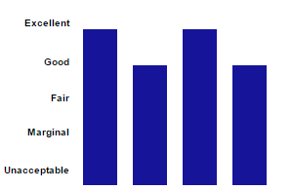
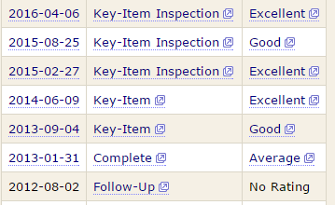

2) Smiley Faces

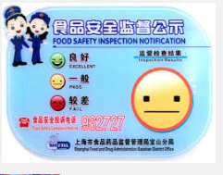

3) Above average, average and below average
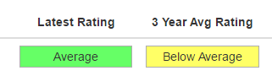

4) Numerical Score
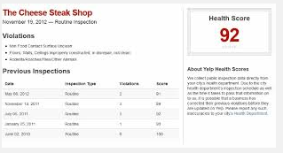

5) Speedometer
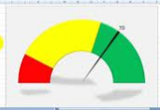

6) Pass, Conditional Pass, Closed or related. Such as Pass/Fail, Meets Standards/Doesn’t Meet Standards, etc.
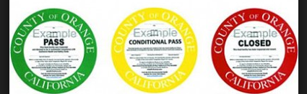

7) Stars
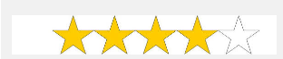

8) Maybe combination of some
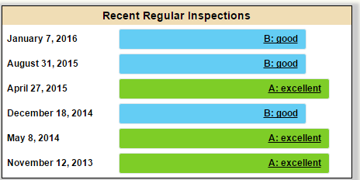
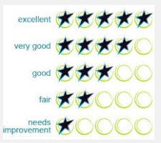

Locations that use numerical scores
- San Francisco
- Seattle/ King County
- State of Alabama
- Washington State
- Austin Texas
- City of Dallas

Locations that use grades:
- Las Vegas/ Clark County
- Los Angeles
- New York City
- Maricopa County AZ

